QS License Server

The Quikscribe License Server application is installed on the network file server and automatically registers each QS Recorder and QS Player license when those programs are run on client user machines.

QS License Server eliminates the need to manually register each computer for QS Recorder or QS Player.

To accomplish this:
- Install the QS License Server application on the network file server, then either manually start it or restart the server.
- In QS Manager, select Admin Tools, then Concurrent License Servers, and click on the desired server from the list. From here you can register the license keys for QS Recorder and QS Player and monitor the individual registrations.
- In QS Recorder and QS Player, select Help, then Register (or License Info) and select the option for “Concurrent Licensing”

Details follow:

- Download the QS License Server application from www.digidictate.com/install and run the installation program on your network server. IMPORTANT: All client computers must be have network access to the server in order to obtain a valid license from the QS License Server.

To start the QS License Server, either restart the server, or bring up the Windows Services panel by right-clicking on Computer (or My Computer), then select Manage, then Services and Applications, then Services. In the Services panel, locate “Quikscribe License” in the list, then right-click on it and select “Start”.

Once the QS License Server is installed and running on the server, you’ll see it as a running service in Windows Services:

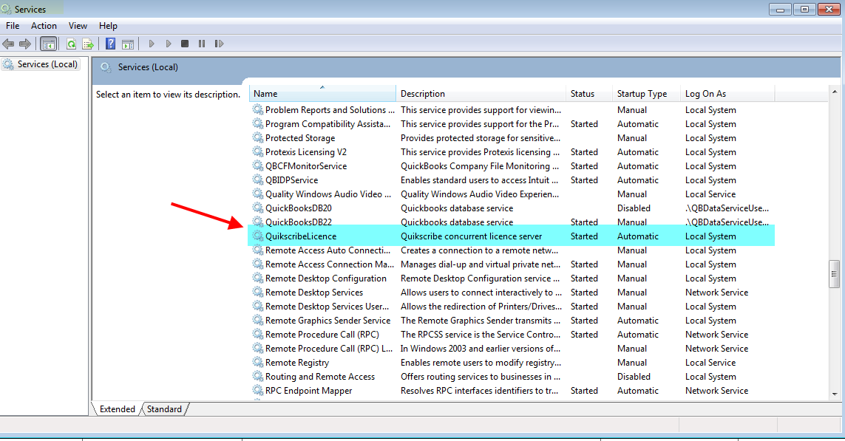

- From QS Manager you can access the QS License Server registration and view the computers that have engaged the license server.

If this is a new installation for QS Manager (and it has not been registered), then you’ll need to register QS Manager by selecting Help, then Register, and then click on the desired license server:

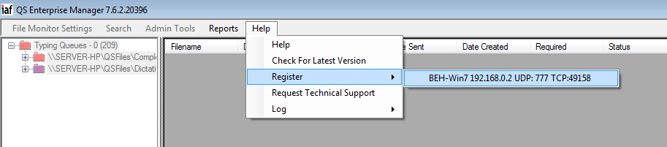

The License Database Interface panel will display. Paste the Manager license key in the entry panel and select “Register”, and then click “Register” again to confirm the registration. A confirmation panel will display showing the product is registered.
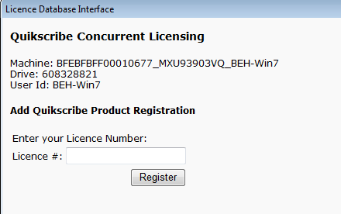

Once the QS Manager is registered, you can also enter the license keys for QS Recorder and QS Player in this entry panel. Once those products have been registered, you should see a panel that looks something like this:
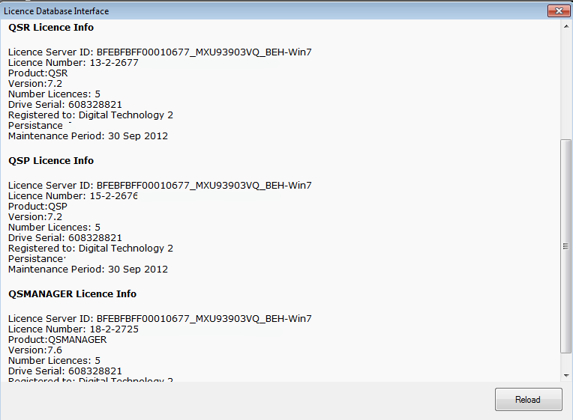

- In QS Recorder and QS Player, you engage the automatic license feature by selecting Help, then Register (or License Info), and then check the selection for ‘Concurrent Licensing’: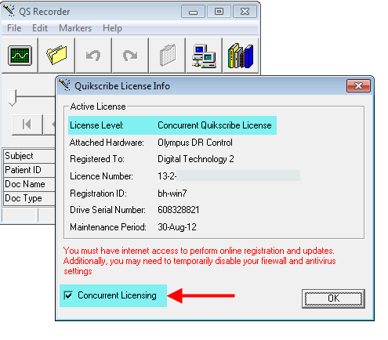
Once this is selected, QSR or QSP will automatically register the software using the license information obtained from the server and the QS License Server application that is running on the server. (You won’t need to manually register QS Recorder or QS Player).

Each time a program is executed, a QSR or QSP license is reserved for that computer.

Now that the products are registered and the settings updated in QSR/QSP, go into select Admin Tools, then Concurrent License Servers, and then select the license server from the list:

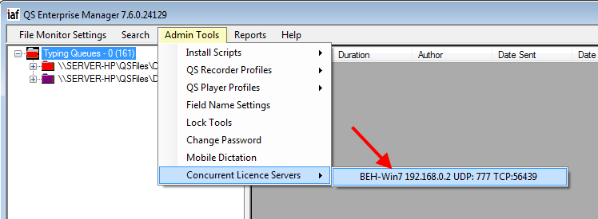

The License Activity Form displays the maximum number of licenses available for each product. The Issued column displays the number of licenses that have been engaged for each product.

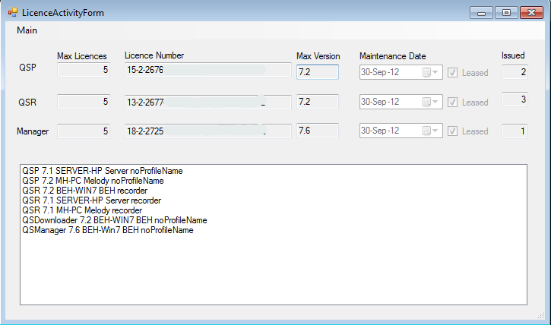

Additional Notes:

If there is no Manager registration on the server, the server will appear as a menu item under the Register menu item (under Help). The License Server may be registered initially from there.

If unable to connect to the license server, QS Recorder and QS Player have full ability for 30 minutes provided QSR/QSP has been able to obtain a license from a server within the past five days. QSR/QSP may be restarted for an additional nine times before converting to DEMO mode.

If a computer fails, the license is retained for five days and then released automatically. As QSR and QSP provide 30-day trial periods, a new computer can register automatically after 5 days if it is replacing the failed computer and all other licenses are fully engaged. (Immediate license replacement is available as an option).

