Interfacing documentation for the Concurrent Licence Server

Contents

Contents 2

1 GENERAL 3

2 PURPOSE 4

3 REFERENCES 4

4 OVERVIEW 5

5 Installation 5

6 Method of operation 5
6.1 Registration of Product Licences 5
6.2 Registration of Quikscribe products with Quikscribe Licence Server 6
6.3 Monitoring Licence Activity 6

7 Troubleshooting 6
7.1 Test Service is Running 7
7.2 Running diagnostic application 7
7.3 Test with Quikscribe Manager 8
7.4 Checking registry 9

GENERAL

This Design Document is issued for approval. It is not authorised for distribution. It will be subject to review and amendment in accordance with the document control procedures in the Project Plan.

Date / /

(Project Manager)

Version No. | Revision Description | Date | Pages Affected | Quikscribe Reviewer
Draft | Draft Issued for Comment & Approval | 18-Jan-13 | All | A. Fraietta

PURPOSE
The purpose of this document is to define the methods used to integrate the Quikscribe Concurrent Licence Server to facilitate site licensing of Quikscribe Products.

REFERENCES
Interfacing documentation for Quikscribe Profiles
RFC 768 - User Datagram Protocol
RFC 760 - DoD standard Internet Protocol
RFC 793 - Transmission Control Protocol

OVERVIEW
The Quikscribe Concurrent Licensing system enables Quikscribe products to be concurrently licensed over a site. For example, if the licence server has fifty Quikscribe Player licences enabled, it will enable the licences of fifty instances of Quikscribe Player at any one time. This becomes particularly effective when the software is run by different users on different computers and removes the requirement of transferring licences from one computer to another.
An additional feature of this system is that it is possible to monitor which computers are active at any time through the use of the Quikscribe Manager.

Installation
The Quikscribe Concurrent Licence Server is installed as a Windows® system service that runs on start-up on the computer that will act as licence server. The service does not have a user interface and does not need a user login for it to operate. The Quikscribe Manager is required to communicate with the Licence Server in order to install Quikscribe licences to the service, to monitor how many licences are installed, and to see how many licences for each product are in use. The Quikscribe Manager can be run on any computer that is connected on the same local area network as the Quikscribe Concurrent Licence Server.

Method of operation
There are primarily three operating functions within the licensing package: registration of Quikscribe product licences to the Quikscribe Licence Service, issue of product licences from the licence server to Quikscribe products (such as Quikscribe Player, Quikscribe Recorder, etc…), and monitoring of licence activity of the licence server.

Registration of Product Licences
Licences are stored to the Quikscribe Licence Server computer through the Quikscribe Manager. This is required because the licence service does not have a graphical user interface. After establishing a connection between the Quikscribe Manager and the Quikscribe Licence Service, the licence service passes the unique identification details of the computer running the licence service to the Quikscribe Manager. The Quikscribe Manager then passes this information to the online Quikscribe Licence Database, and after entering the licence number and registering it, the information about the Quikscribe Licence Service is stored online. At this point in time, the Quikscribe Licence Service has not yet detected that it is registered. The Quikscribe Manager then sends a message to the Quikscribe Licence Server to initiate a licence status test.
The Quikscribe Licence Service checks the online database, and if it detects that it is registered, stores the information to the licence server registry.

Registration of Quikscribe products with Quikscribe Licence Server
Quikscribe products, such as Quikscribe Player and Quikscribe Recorder, obtain a licence from the Quikscribe Licence Service through the User Datagram Protocol (UDP). The Quikscribe product opens a UDP port and then sends a broadcast message to the Quikscribe Licence Service over ports 777, 778, 779, 888, and 889, passing its own port as a parameter. When the Quikscribe Licence Service receives the packet, it returns a packet to the IP address of the Quikscribe product on the port number that was specified by the Quikscribe product. In cases where UDP broadcast messages are blocked, the IP address or server name can be entered into the Quikscribe product, causing the Quikscribe product to send messages directly to the licence server’s IP address.
In many cases, installed firewalls prevent applications from sending any messages. Quikscribe attempts to overcome this by sending a file over FTP to the Quikscribe online database, causing the firewall to prompt the user to unblock the application. This should only happen once.
The Quikscribe product will continue to communicate with the Quikscribe Licence Service while it is running.

Monitoring Licence Activity
The Licence activity is monitored using the Quikscribe Manager, which does not need to be on the same computer as the Quikscribe Licence Service. More than one Quikscribe Manager can connect to and monitor licence activity concurrently from the Quikscribe Licence Service. The Quikscribe Manager initiates an exchange over UDP, similar to the way the Quikscribe product does, and populates a menu on the Quikscribe Manager. The Quikscribe Licence Service provides TCP information. When the user selects which licence service he or she wants to monitor, the Quikscribe Manager makes a TCP connection with the Quikscribe Licence Service. All licence activity that occurs from the Quikscribe Licence Service will be pushed to all the connected Quikscribe Managers, which will all display the activity in real time.

Troubleshooting
Communication over networks is often restricted in enterprise environments. These restrictions include firewalls and proxies, coupled with application restrictions to resources such as the Windows Registry and file system. Troubleshooting techniques such as writing to log files and displaying messages to a user interface is not possible on the Quikscribe Licence Service because the application does not allow a user interface by virtue of the fact that it is a system service. Quikscribe has provided a diagnostic tool called LicenceServerDiagnostic.exe that behaves like the Quikscribe Licence Service, with a facility to display messages from the Quikscribe Manager and Quikscribe Products.

Test Service is Running
The first test is to actually see whether the Quikscribe Licence Service is actually started by checking service manager in control panel.
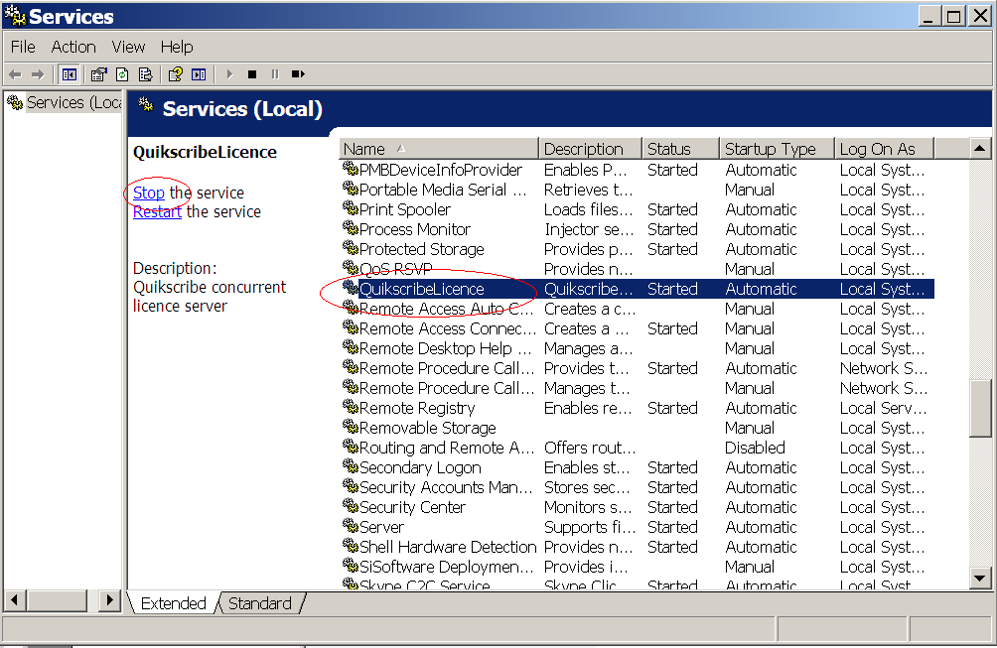

If the service is not running, click on start. If it is running, you will need to run the diagnostic application.

Running diagnostic application
In order to run the diagnostic, stop the Quikscribe Licence Service from service manager in Control Panel. Then, find and run the diagnostic application from Windows Explorer.
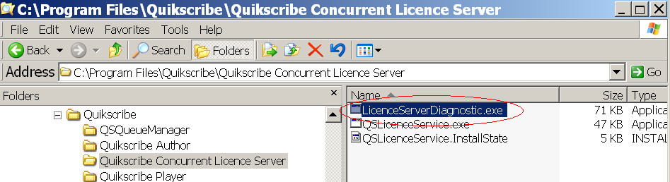

After starting the program, run a Quikscribe product, such as Quikscribe Player. Messages should begin to appear, as shown in the diagram below.
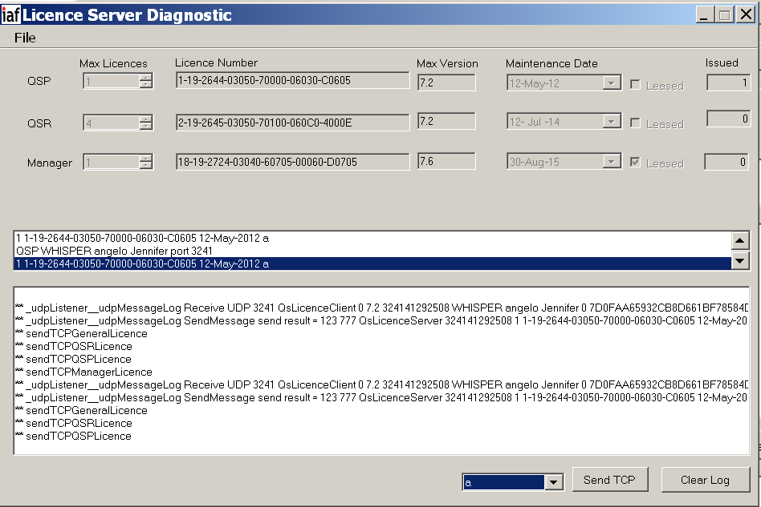
If there are no messages, this indicates that UDP messages are not being received in the diagnostic program. This would be caused by a firewall blocking the application or broadcast addresses being blocked. If this test passes, and no licences are displayed, test for communication with Quikscribe Manager.

Test with Quikscribe Manager
Run the same test with the Quikscribe Manager. If a successful connection is made, the Quikscribe Manager should have the information about diagnostic application displayed in a menu item.
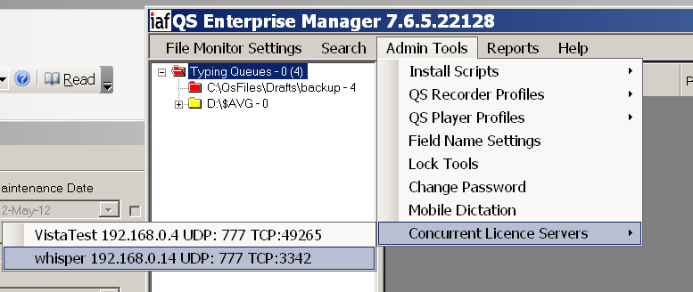
Select the server, and then select “Server Registration” from the main menu. On the diagnostic app, select “Go online” from the file menu. Compare the machine information between the two and confirm that they are identical as below.
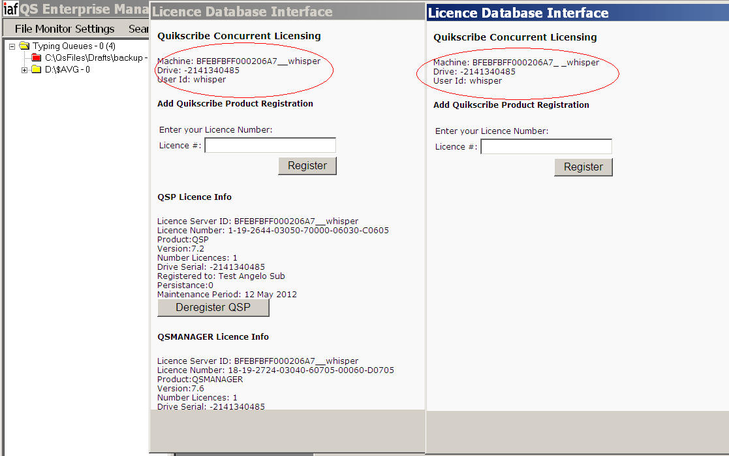

Checking registry
If you have entered the correct licence information, licences appear registered from Quikscribe Manager, but do not show up on the diagnostic front display, check to see if the data has been written to the registry.
